The following the communication fee rules of Chung Hwa Telecom. I suppose you fully understand the rules. If not, ask Chung Hwa Telecom.

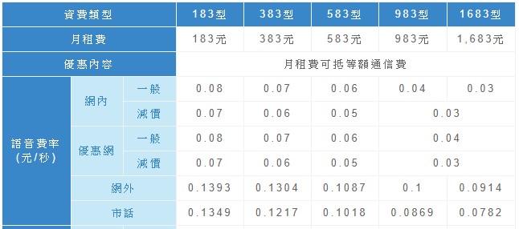

Suppose the company use stored procedure to calculate the communication fee for all customers at the end of each month, and all the customers have used the mobile service for a full month.

Please write a stored procedure to calculate the bill for a customer. The parameter of the stored procedure is the telephone number of the customer. The following are the tables related to the bills.

Table Customer, having Customer Name, Telephone Number, and fee type (like 183型) attributes

Table Buddy, having telephone number of Customer Name, telephone number of his/her buddy.

Table voiceTime, having customer phone number, receiver phone number, start time (in the format, hh:mm:ss) and timespan (in second) attributes.

Table discountTime, having start time and end time attributes (both in the format, hh:mm:ss)

Note that if the telephone number of receiver cannot be found in the Customer Table, the number is classified as inter-communication(網外); otherwise, intra-communication (網內).